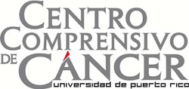
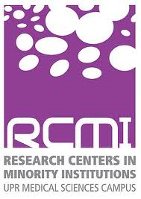
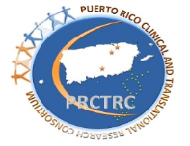

Puerto Rico Omic (PROMIC)
Application Form
To request our services, please send the completed Application Form with the required documents to: Incomplete applications will not be evaluated.

Evaluation process for this application can take between 2 to 3 working days.

Request for PROMIC Service (s)

Please select which service(s) you want to receive. (Select all that apply)
Puerto Rico Omic Center
 | DNA extraction and QC |  | Quantitative PCR (QuantStudio6)  Specify:
 | RNA extraction, cDNA template preparation, and QC |  | Droplet digital PCR (BioRad QX200)  Specify:
 | Library preparation for sequencing and templates preparation |  | Bioinformatics analyses  Specify:
 | DNA/RNA sequencing reactions  Specify:  Illumina Platform Ion Torrent Platform |  | Proteomic Assays  Specify:
 | Affymetrix Microarrays  Specify: |  | Metabolomics  Specify:
 | iScan BeadArrays  Specify: |  | Other, Specify:

Contact Information - Principal Investigator or Contact Person

- First Name:
- Last Name:
- Degree:
- Current Position:
- Institution:
- School:
- Department:
- Program:
Email:
Telephone:
- Study Description
Please indicate information regarding the research protocol from the biological samples was collected.
- Full title of the study:
- Research Areas: | Cardiovascular | HIV
 | Cancer | Neuroscience
 | Other, specify:
- IRB/IACUC Number:
- IRB/IACUC Expiration Date (mm/dd/yyyy):
- Institutional Biosafety Committee (IBC) Expiration Date (mm/dd/yyyy):
Please provide a brief study description:

- Biological Samples Descriptions

Please provide information related to the biological samples that will be used through the PROMIC.
Type of biological sample:
Type of organism:
Number of biological samples:
Number of runs per biological samples:

- Investigator’s Responsibilities
- Acknowledgements of Support: Each publication, press release or other document that results from NIH grant support and disclaimer such as: The project was supported by the Puerto Rico Omics Center (PROMIC) at the University of Puerto Rico Comprehensive Cancer Center and by NIH awards: RCMI: U54 MD007600, PRCTRC: U54 MD007587, PRIMBRE: P20 G103475, MBRS SCORE: SC1 HL123911.
- The PROMIC is committed in providing each study the best possible service.

I, , agree to fulfill the Investigator’s responsibilities and submit the information requested by PROMIC.

Please provide an electronic signature.

Date submitted _{(mm/dd/yyyy)}:

