

**Policy 1: DETERMINING WHETHER A RESEARCH ACTIVITY NEEDS IRB REVIEW AND APPROVAL**

## 1. Subject

All research activities that involve the collection of information through intervention, interaction with, or observation of individuals, or the collection or use of private information about individuals, must be evaluated to determine whether they constitute human participant research, and the type of review required before the research activities can begin. This policy provides guidelines for making this determination and outlines the appropriate review requirements.

## 2. Scope

All UPR Comprehensive Cancer Center (CCC-UPR) IRB Policies & Procedures apply to all human participant research projects conducted by CCC-UPR faculty, staff, or students or by anyone conducting research in which the participation of CCC-UPR meets the definition of “engagement” as indicated by the Office of Human Research Protections (OHRP) (<https://www.hhs.gov/ohrp/>).

## 3. Policy Statements

* The researcher is responsible for ensuring full and continuing compliance with all University and IRB policies in the conduct of his/her research.
* A researcher may, in consultation with the IRB Administrative staff or using the Decision Tree (http://www.irb@cccupr.org), make a self- determination whether the proposed research activitydoes or does not constitute human participant research.
* If the research activity **does not** constitute human participant research, the researcher may initiate the research without review or approval by the IRB.
* If the research activity **does** constitute human participant research, the researcher must submit a completed application to IRB for review. Research activities may not commence until the researcher receives a written letter of IRB approval or a notice of exemption from IRB review. Investigator self-experimentation is considered to research with human participants (see Addendum).

## 4. Procedures

Consult the Flowchart below for a high-level outline of next steps. For detailed policy and procedure requirements for each review type, consult IRB policies 2 and 3

## Chart 1: Is an Activity Research Involving Human Subjects?

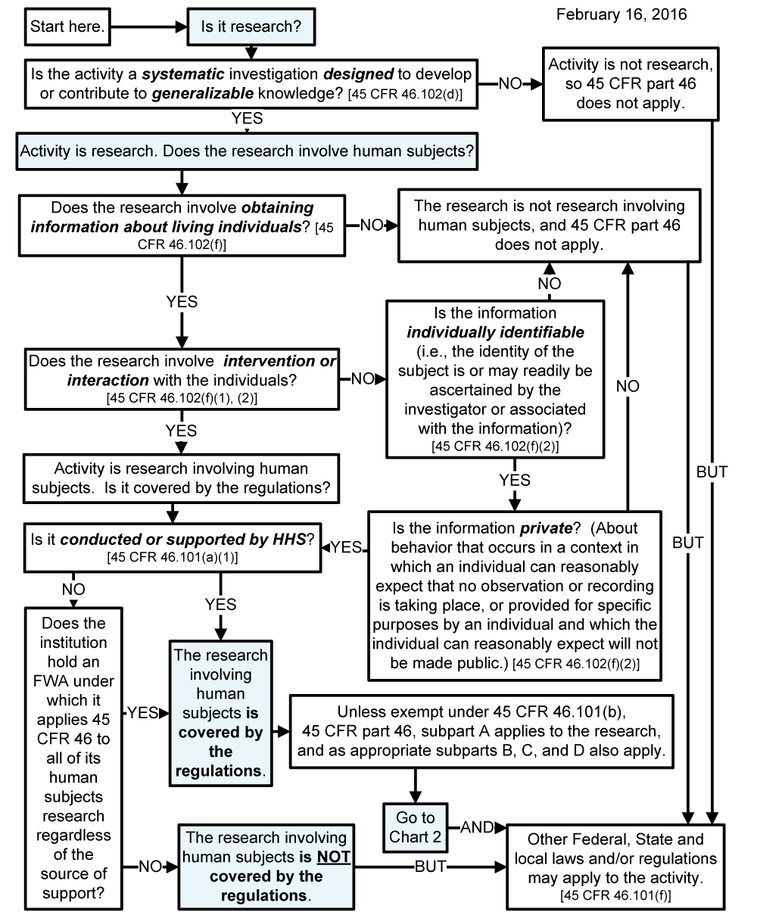

4.1. Research activities that **do not** constitute Human Participant Research

* The Principal Investigator (PI) should consult the Decision Tree entitled “Is your activity covered under the Human Research Protection Program?” or consult with IRB to determine whether the research activity does or does not constitute human participant research.
* If the PI determines that the research activity does not involve human participant research, s/he may initiate the projectwithout seeking approval from the IRB, and is not required to complete the CITI Human Participant training.
* For each change that is proposed or occurs during the execution of the research, the PI may need to re-consult the IRB Decision Tree to determine whether that change affects the classification of the project as “not human participant research.”

4.2. Research activities that **do** constitute Human Participant Research

* If the research activity does involve human participant research, the PI must complete and submit to IRB a Request for Exemption from IRB Review Form or an Initial Approval Request Form and instruments required for review, See IRB forms web page and IRB Policies 2 and/or 3 for the submission requirements.
* No research activities may begin until the PI receives a written letter of IRB approval or notice of exemption for the protocol from IRB.

4.3. Research activities that are eligible for Exemption from IRB Review

* If IRB determines that, the research project is human participant research but eligible for exemption from IRB review, the IRB Administrator will issue a formal notice of exemption to the PI.
* The IRB will archive a copy of this notice and all submission documents until five years after the termination of the research activity. Also, the PI should maintain these documents for five years after the research activity has concluded and all publication and/or reports have been accepted.
* For each change that is proposed or occurs during the execution of the research activity, the PI should consult with IRB to determine if the change affects the eligibility of the research activity to continue to be exempt from IRB review and approval.
* Consult IRB Policy 2: Determining Research Eligible for Exemption from IRB Review, for requirements and procedures for review and continuing approval of requests for exemption.

4.4 Research activities that require IRB Review and Approval

* For research activities that are determined to require IRB review and approval, IRB staff will review applications and instruments for completeness and consistency, and will also confirm completion of Human Participant Research training requirements, then forward the materials to the IRB for review and approval via the Expedited Review Process.
* Research activities that do not qualify for expedited review will undergo Full Committee Review.
* All personnel named on the protocol must complete the CITI human participant training *before* the IRB can approve the protocol. Consult the IRB training sites.
* Consult Policy 3: Expedited and Full Committee Review Procedures for requirements and procedures for review and continuing approval of applications to the IRB.

## 5. Regulations and Guidance Applicable to Human Participant Research Determination

5.1. Federal Regulations

* CCC-UPR has filed a FederalWide Assurance (FWA) with the Office for Human Research Protections (OHRP) of the U.S. Department of Health & Human Services guaranteeing its application of the federal policy for the protection of human participants in 45 CFR 46 when engaging in human participant research funded by the Public Health Service (PHS). By institutional policy, the same standards apply to all human participant research, regardless of funding support. CCC-UPR’s appointment of an appropriately constituted IRB is included in the FWA.
* Requirement for IRB review and approval of human participant research before its initiation: 45 (Code of Federal Regulations (CFR)) 46.108(b)
* Definitions of human participant research: 45 CFR 46.101-103.

5.2. Ethical Codes

* The Nuremberg Code (1948)
* The Belmont Report (1974)
* Declaration of Helsinki (last revised in 2013)

# Addendum

**INVESTIGATOR SELF-EXPERIMENTATION**

Federal regulations are silent on the matter of researchers who want to participate in their studies. However, the regulations do not distinguish between self-experimentation and research on people who are recruited for a specific project. As part of its commitment to the protection of the rights and welfare of individuals participating in research, CCC-UPR's Human Research Protection Program requires investigators who wish to act as participants in their studies to submit for review and approval following standard procedures outlined in the IRB policies (www.irb@cccupr.org).

Though investigator self-experimentation may not raise the common ethical concerns outlined in the Belmont Report (http://www.hhs.gov/ohrp/policy/belmont.html), all human research projects should undergo ethical review to assure the safety of people involved and the integrity of the research at the CCC-UPR. While researchers may be aware of the risks of self-experimentation, they may also be more willing to accept risks that are ill-advised. Application for review with the IRB office allows a neutral third party to raise concerns and/or propose measures to promote the welfare of researchers.